UNITED STATES
SECURITIES AND EXCHANGE COMMISSION
Washington, D.C. 20549

SCHEDULE 14A INFORMATION

Proxy Statement Pursuant to Section 14(a) of the
Securities Exchange Act of 1934
(Amendment No. )

 | Filed by the Registrant |  | Filed by a Party other than the Registrant

Check the appropriate box:
Preliminary Proxy Statement
Confidential, for Use of the Commission Only (as permitted by Rule 14a-6(e)(2))
Definitive Proxy Statement
Definitive Additional Materials
Soliciting Material under §240.14a-12
NUTANIX, INC.

(Name of Registrant as Specified In Its Charter)
(Name of Person(s) Filing Proxy Statement, if other than the Registrant)
Payment of Filing Fee (Check all boxes that apply):
No fee required
Fee paid previously with preliminary materials
Fee computed on table in exhibit required by Item 25(b) per Exchange Act Rules 14a-6(i)(1) and 0-11

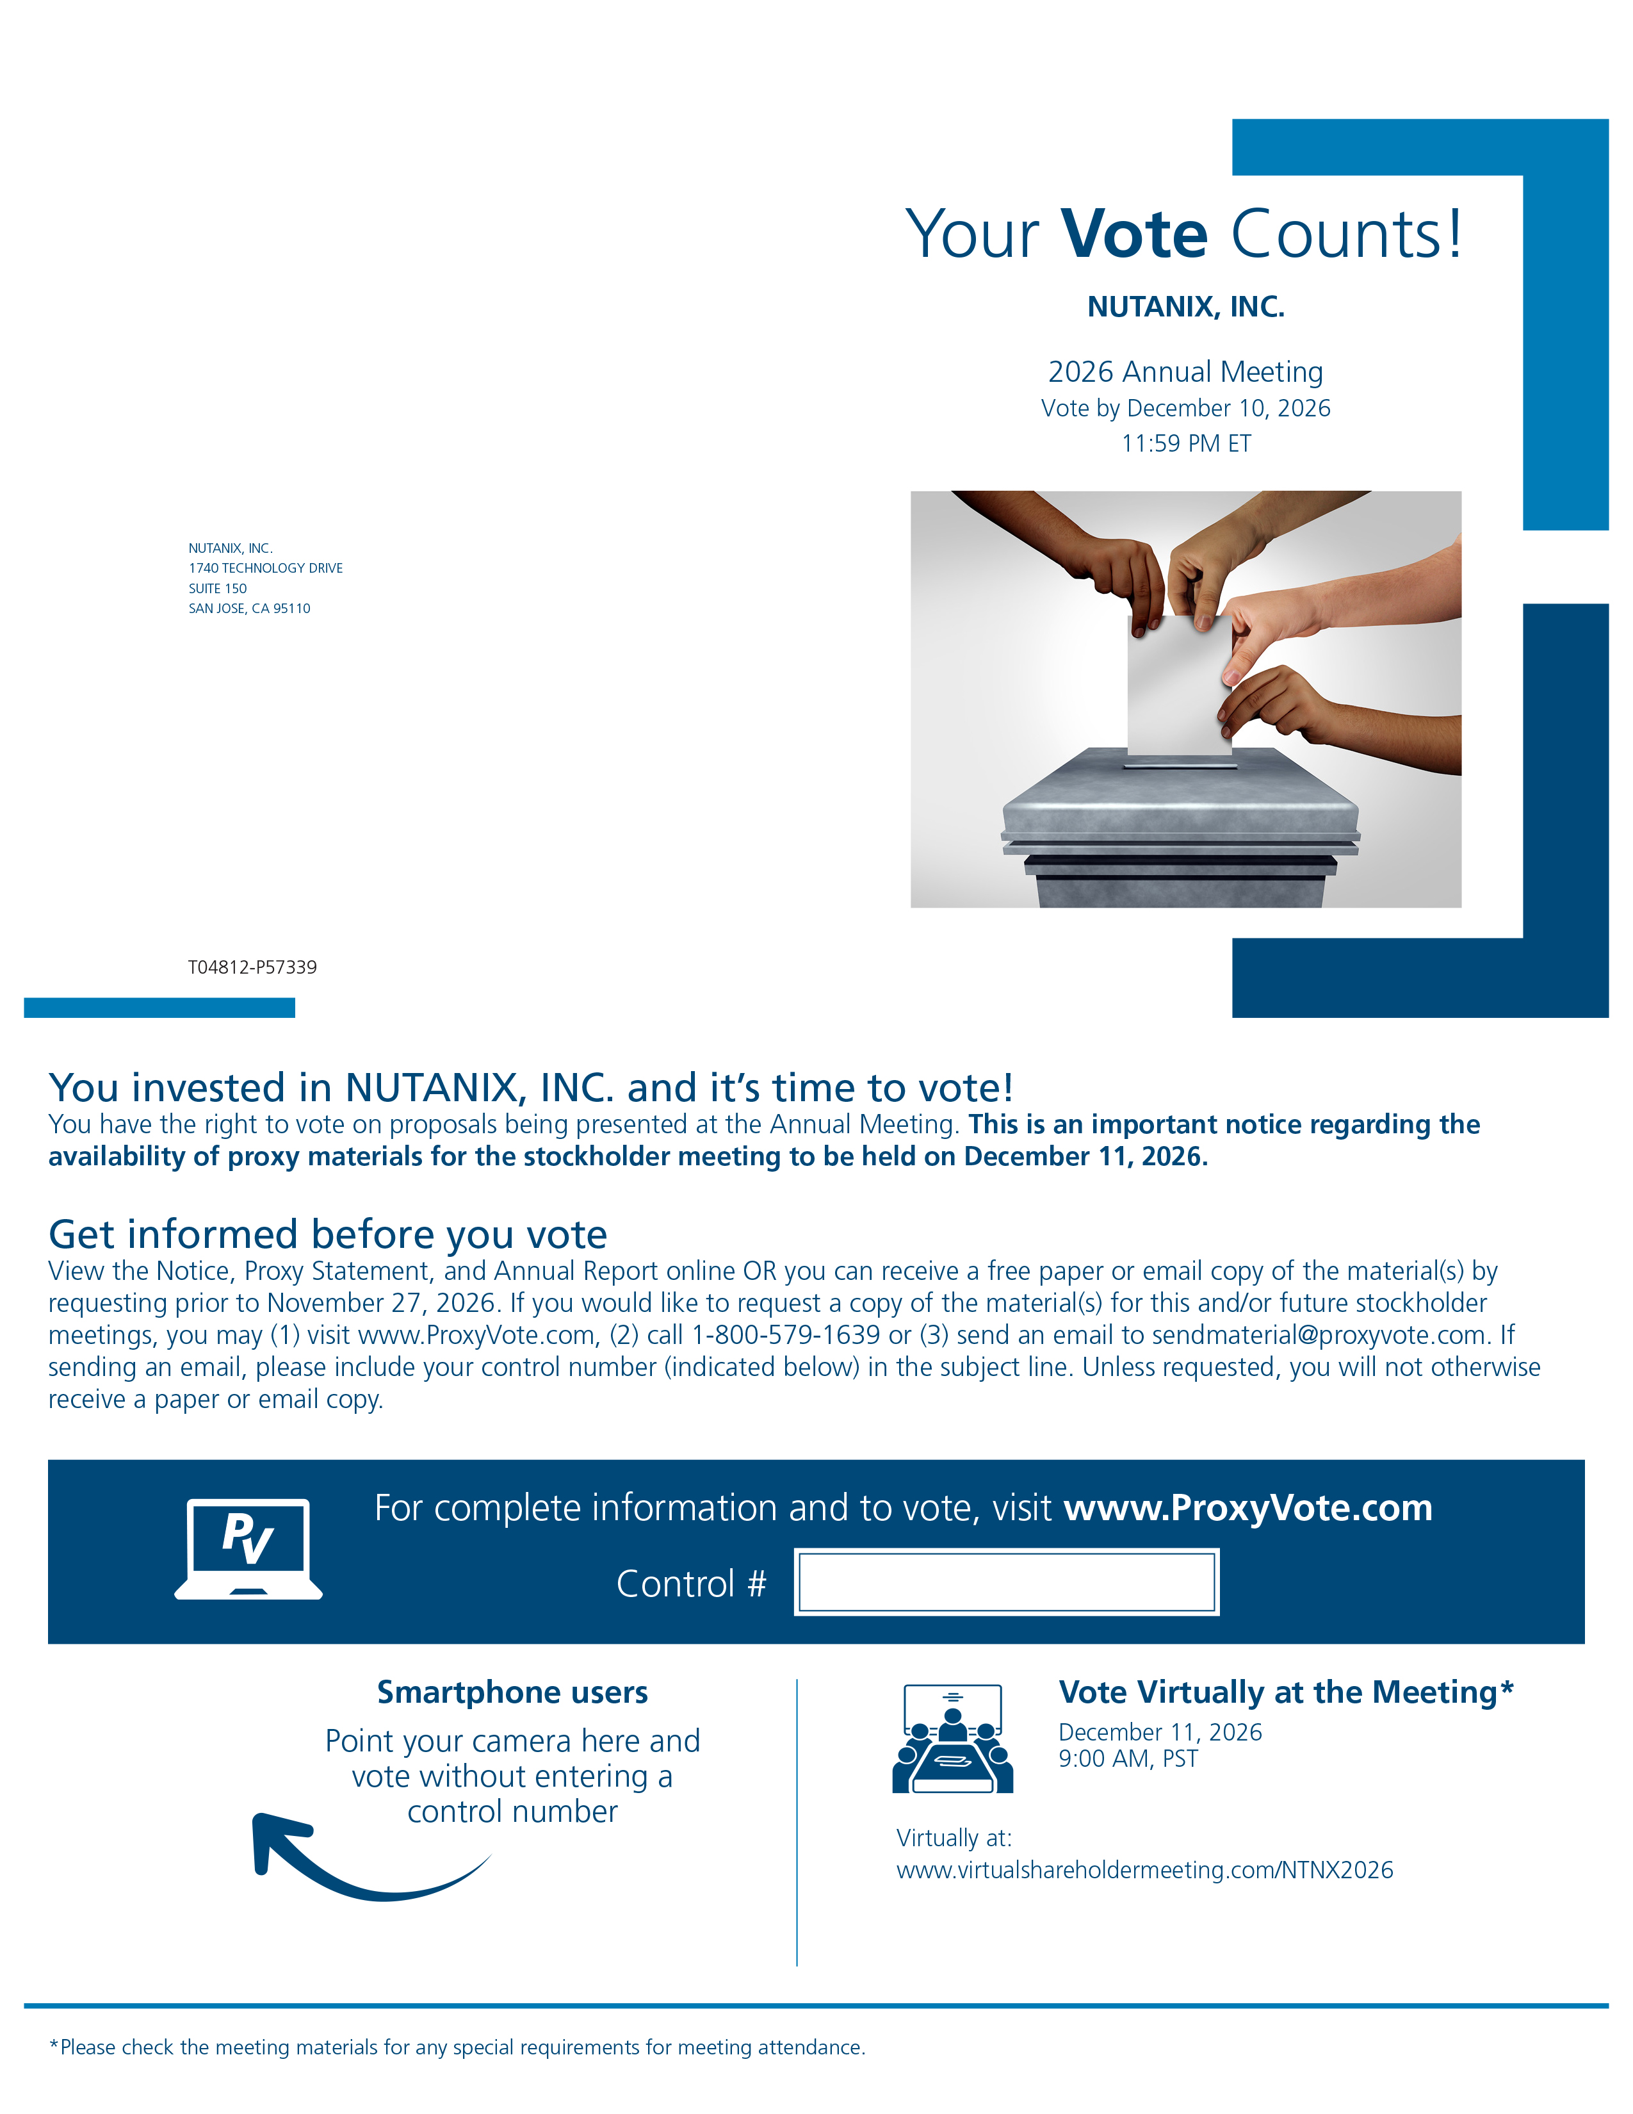

Your Vote Counts! NUTANIX, INC. 2026 Annual Meeting Vote by December 10, 2026 11:59 PM ET NUTANIX, INC. 1740 TECHNOLOGY DRIVE SUITE 150 SAN JOSE, CA 95110 T04812-P57339 You invested in NUTANIX, INC. and it’s time to vote! You have the right to vote on proposals being presented at the Annual Meeting. This is an important notice regarding the availability of proxy materials for the stockholder meeting to be held on December 11, 2026.Get informed before you vote View the Notice, Proxy Statement, and Annual Report online OR you can receive a free paper or email copy of the material(s) by requesting prior to November 27, 2026. If you would like to request a copy of the material(s) for this and/or future stockholder meetings, you may (1) visit www.ProxyVote.com, (2) call 1-800-579-1639 or (3) send an email to sendmaterial@proxyvote.com. If sending an email, please include your control number (indicated below) in the subject line. Unless requested, you will not otherwise receive a paper or email copy.For complete information and to vote, visit www.ProxyVote.com Control # Smartphone users Point your camera here and vote without entering a control number Vote Virtually at the Meeting* December 11, 2026 9:00 AM, PST Virtually at: www.virtualshareholdermeeting.com/NTNX2026 *Please check the meeting materials for any special requirements for meeting attendance.

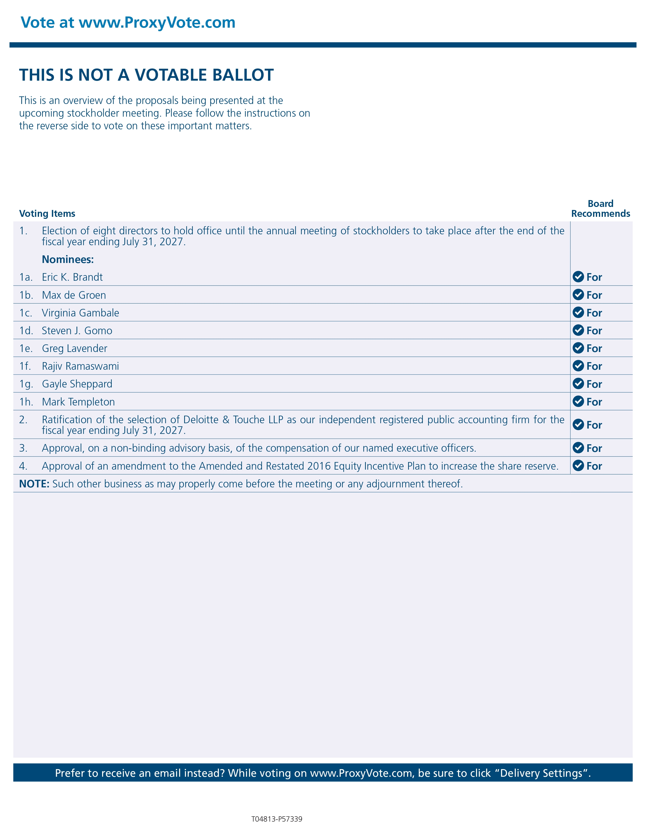

Vote at www.ProxyVote.com THIS IS NOT A VOTABLE BALLOT This is an overview of the proposals being presented at the upcoming stockholder meeting. Please follow the instructions on the reverse side to vote on these important matters.Voting Items Board Recommends 1. Election of eight directors to hold office until the annual meeting of stockholders to take place after the end of the fiscal year ending July 31, 2027. Nominees: 1a. Eric K. Brandt For 1b. Max de Groen For 1c. Virginia Gambale For 1d. Steven J. Gomo For 1e. Greg Lavender For 1f. Rajiv Ramaswami For 1g. Gayle Sheppard For 1h. Mark Templeton For 2. Ratification of the selection of Deloitte & Touche LLP as our independent registered public accounting firm for the fiscal year ending July 31, 2027. For 3. Approval, on a non-binding advisory basis, of the compensation of our named executive officers. For 4. Approval of an amendment to the Amended and Restated 2016 Equity Incentive Plan to increase the share reserve. For NOTE: Such other business as may properly come before the meeting or any adjournment thereof. Prefer to receive an email instead? While voting on www.ProxyVote.com, be sure to click “Delivery Settings”. T04813-P57339 ase the share reserve. For NOTE: Such other business as may properly come before the meeting or any adjournment thereof. Prefer to receive an email instead? While voting on www.ProxyVote.com, be sure to click “Delivery Settings”. T04623-P57339

